Capstone Project - Employee Management System

Revision History

|  |  |  |  |
| --- | --- | --- | --- |
| **Date** | **Version** | **Description of Changes** | **Author** |
| 09/06/2021 | 1.0 | Initial Creation | Srinivasulu Yepuru |
|  |  |  |  |
|  |  |  |  |
|  |  |  |  |
|  |  |  |  |
|  |  |  |  |
|  |  |  |  |
|  |  |  |  |
|  |  |  |  |

Table of Contents

1 Objective 4

2 Introduction 4

3 Prerequisites 4

4 Users 4

5 UseCase Diagram 5

6 Class Diagram 6

7 Sample Screen shots 7

7.1 Role: Admin User 7

8 Tech Stack 10

## 1.Objective

The main objective of this capstone project is to enable the learners to apply and integrate the knowledge gained in e-learning and ILT courses.

## 2.Problem Statement

Develop a simple Employee Management System App is using Spring Boot and REST API. This Application should have a CRUD (Create, Read, Update, Delete) .This Application using Angular 8 as a front-end and Spring boot 2 restful API as a backend.

The Application should have the following features:

* Create an Employee
* Update an Employee
* List of Employees
* Delete Employee
* View Employee

Learners should implement below functionality using Spring Boot REST API.

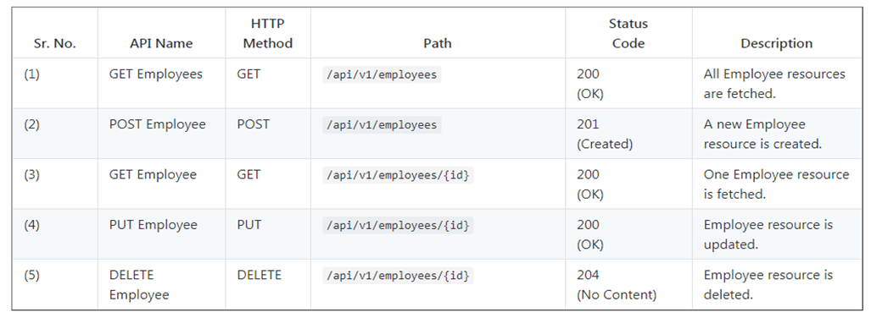

## 3.Prerequisites

Learners should complete both e-learning and ILT courses before to start developing Capstone Project.

## 4.Users

|  |  |  |
| --- | --- | --- |
| **S.NO** | **Roles** | **Functionality** |
| 1 | Normal User | List Employees |
| 2 | Admin User | Create,Update,List and Delete Employees |

## 5.UseCase Diagram

|  |  |
| --- | --- |
|  |  |

## 6.Class Diagram



# 7.Sample Screens Shots

## 7.1.Role: Admin User

Create /Update/List/Delete/View Employee

**Employee List Page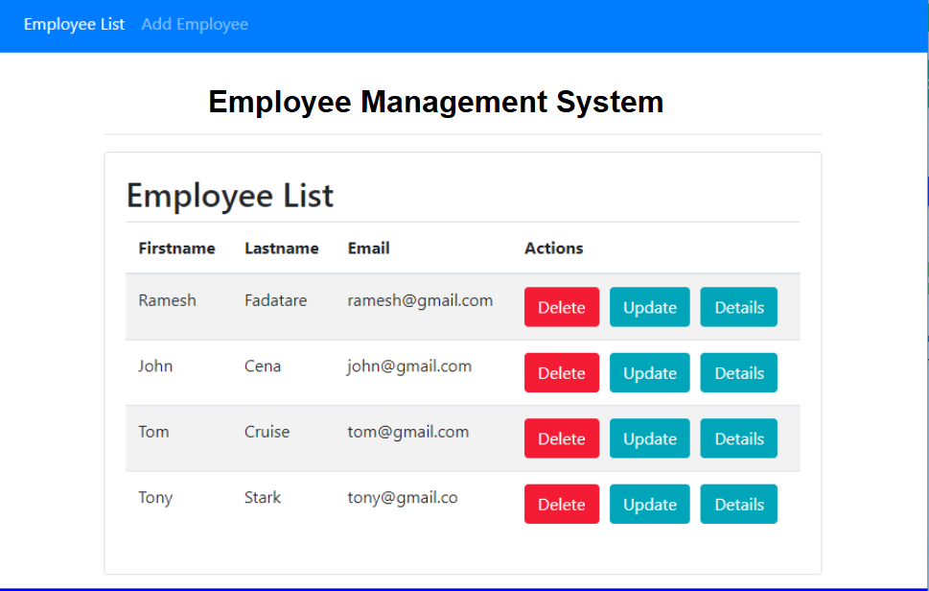Add Employee Page**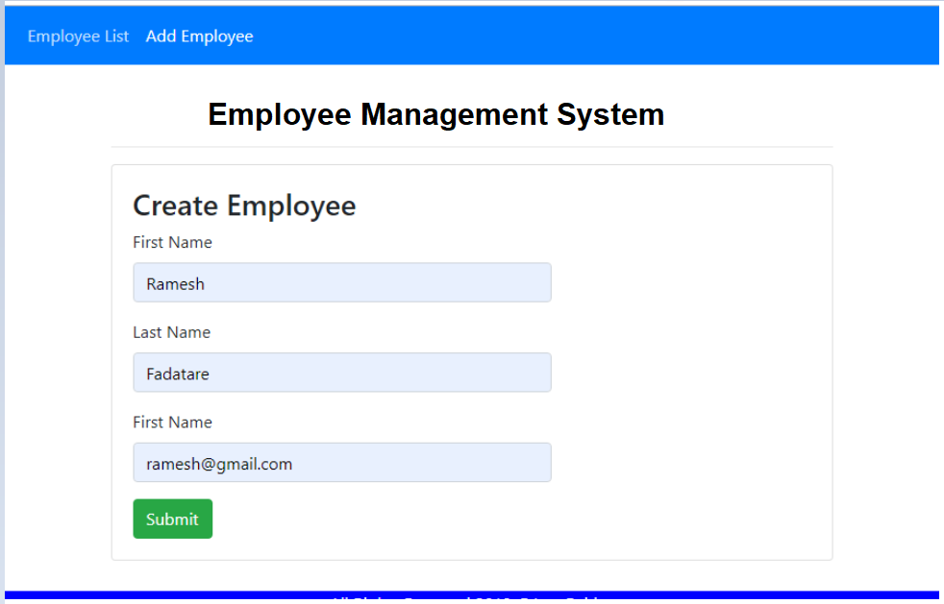

**Update Employee Page**

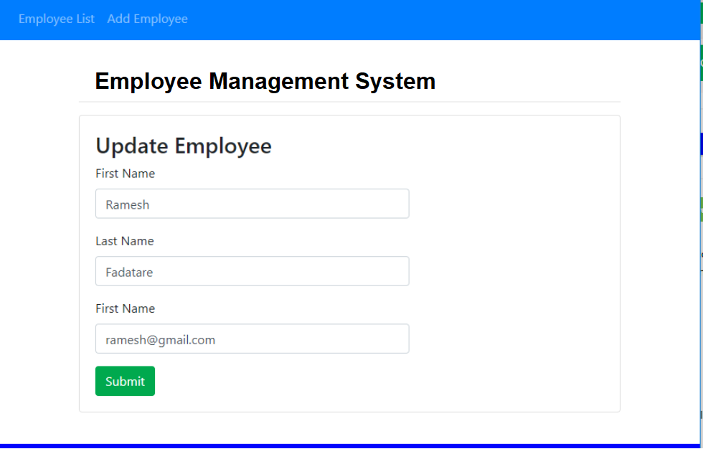

**View Employee Details Page**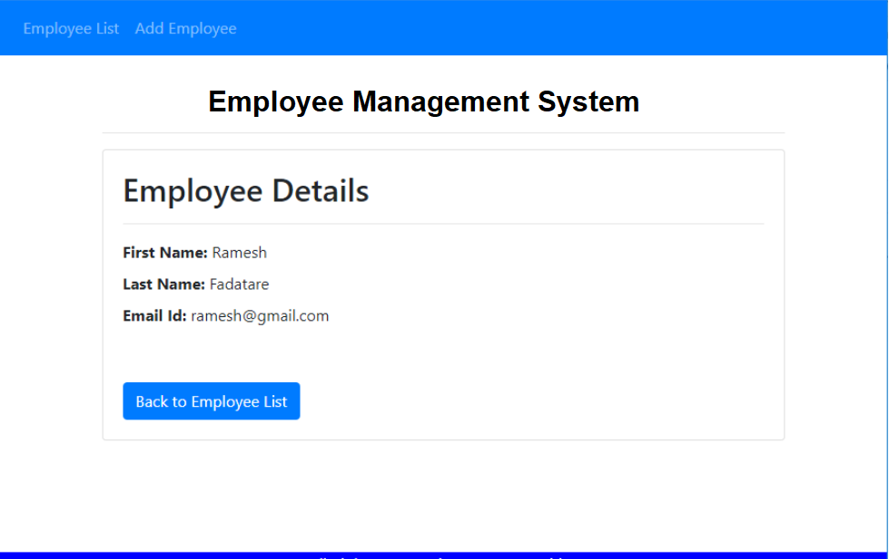

**Delete Employee**

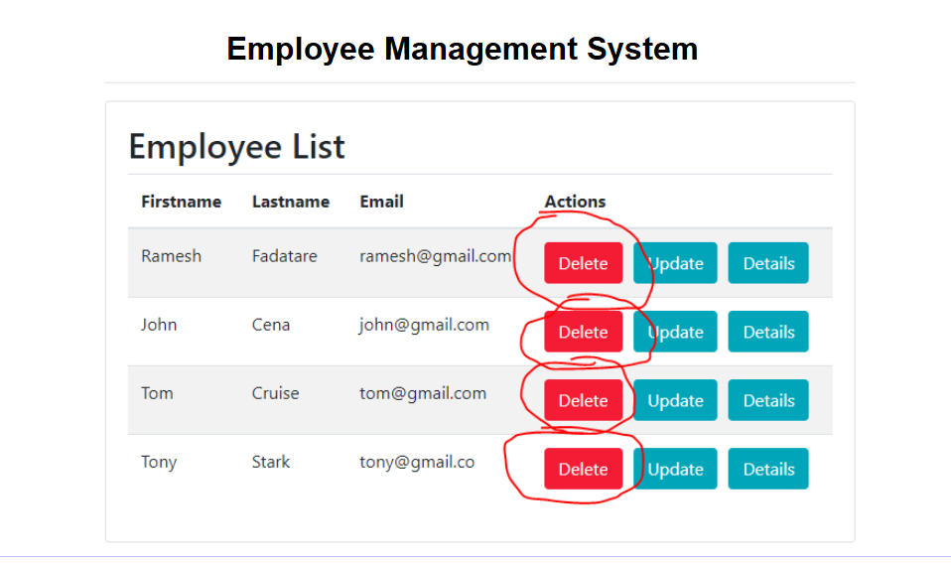

# 8.Tech Stack

|  |  |  |
| --- | --- | --- |
| **Technologies** | **Versions** | **Comment** |
| Maven | 3.0 |  |
| Java | 1.8 |  |
| Spring Boot | 2.0.4 |  |
| Eclipse IDE | Oxygen |  |
| MySQL | 5.5. |  |